# Music Recommendation System

## Dataset and its features:

The content-based filtering method is based on the analysis of item features. It determines which features are most important for suggesting the songs. For example, if the user has liked a song in the past and the feature of that song is the theme and that theme is party songs then Recommender System will recommend the songs based on the same theme. So the system adapts and learns the user behavior and suggests the items based on that behavior. In this project, we are using the Spotify dataset to discover similar songs for recommendation using cosine similarity and sigmoid kernel.[2]

* + - **Acosticness:** confidence measure from 0.0 to 1.0 of whether the track is acoustic.
    - **Danceability:** measure describes how suitable a track is for dancing.
    - **duration_ms:** is the duration of the song track in milliseconds.
    - **Energy:** represents a perceptual measure of intensity and activity.
    - **Instrumentalness:** predicts whether a track contains vocals or not.
    - **Loudness:** of a track in decibels(dB).
    - **Liveness:** detects the presence of an audience in the recording.
    - **Speechiness:** detects the presence of spoken words in a track
    - **Time_signature:** is an estimated overall time signature of a track.

These attributes can be used to train a machine learning model to predict the music recommendation system. The model can be trained using a variety of machine learning algorithms, such as KNN.

**BUILDING PREDICTION MODEL**

The service uses 3 models to create playlists with recommendations:

* + - **collaborative filtering**: Collaborative filtering is a technique that can filter out items that a user might like based on reactions by similar users. It works by searching a large group of people and finding a smaller set of users with tastes like a particular user.
    - **NLP for text analysis:** NLP methods can help the user to provide search input in a free form and without any restrictions, according to the system’s requirements, to get an answer to the desired request.
    - **audio models for audio file analysis:** Audio analysis is a process of transforming, exploring, and interpreting audio signals recorded by digital devices. Aiming at understanding sound data, it applies a range of technologies, including state-of-the-art deep learning algorithms. Audio analysis has already gained broad adoption in various industries, from entertainment to healthcare to manufacturing. Below we’ll give the most popular use cases.

# **Music Recommendation System using KNN Algorithm**

## Import the necessary data.



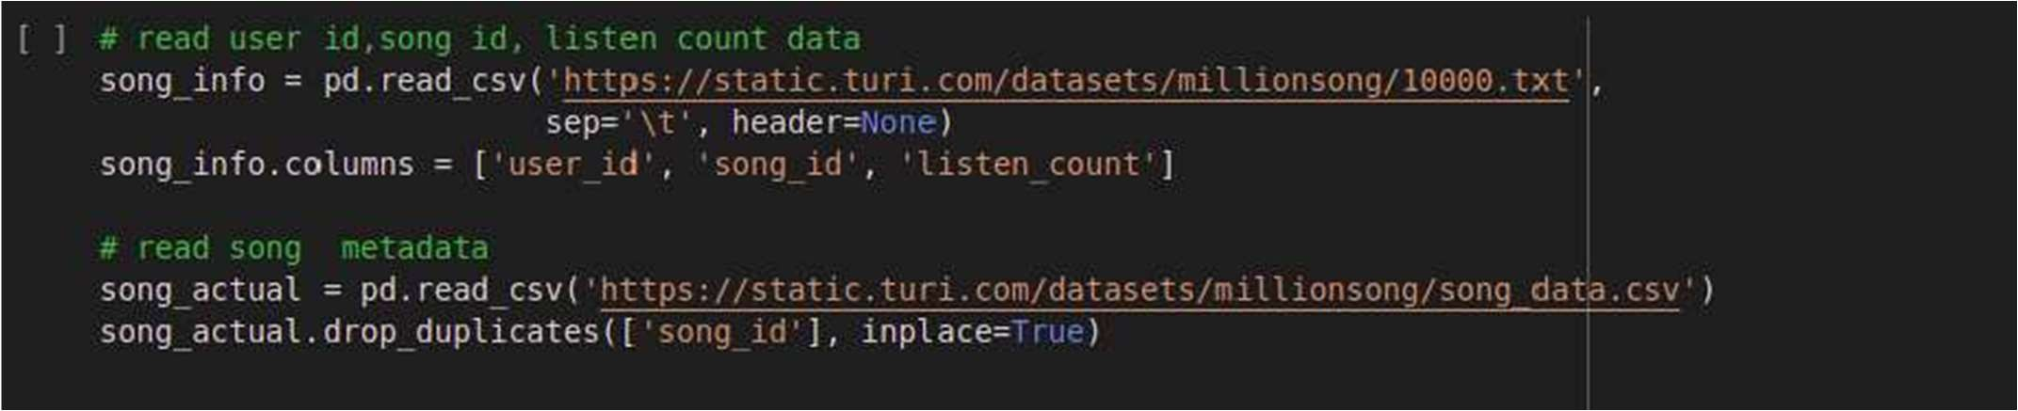

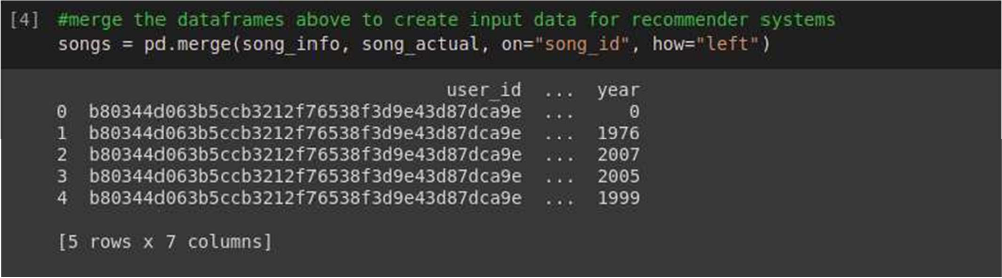

**Get statistics of the top 10 most played songs and artists**



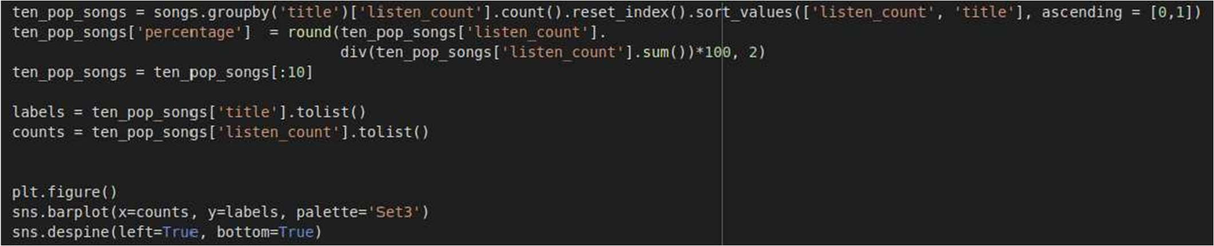

### This is top list from dataset.

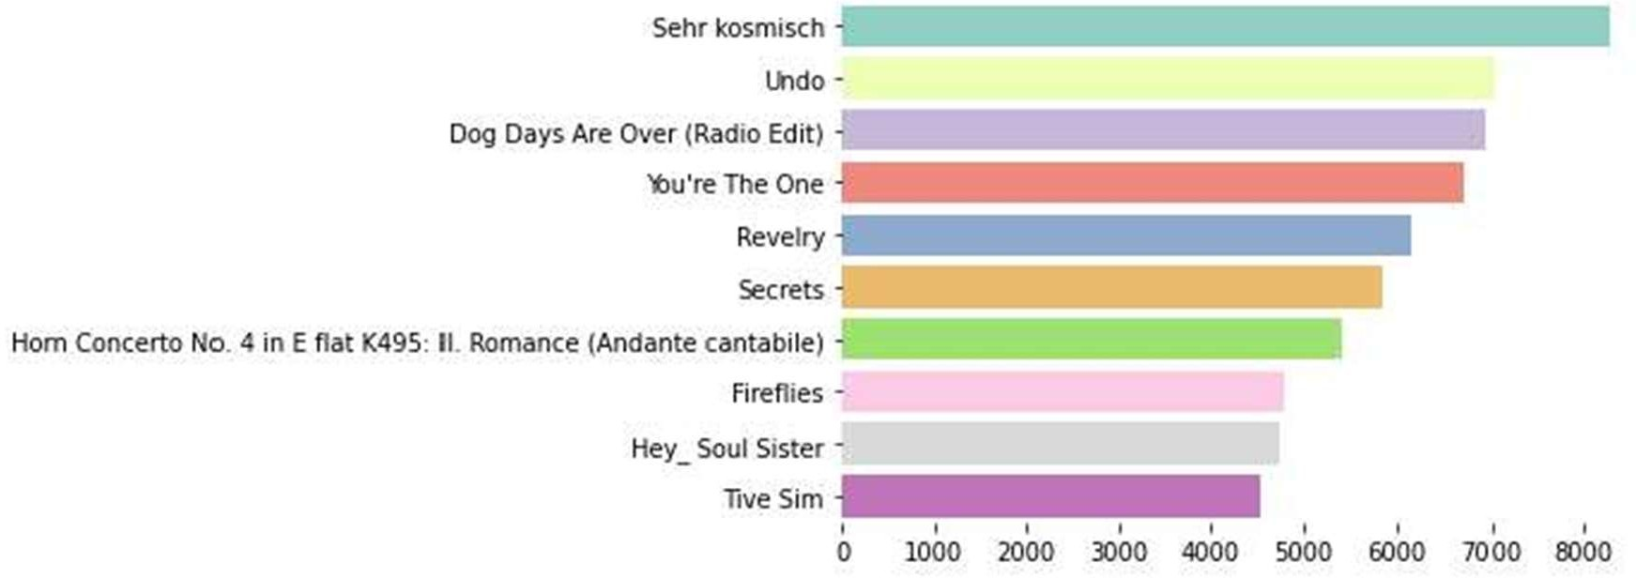

**Fig : statistics of top 10 most played songs**

## Prepare the data

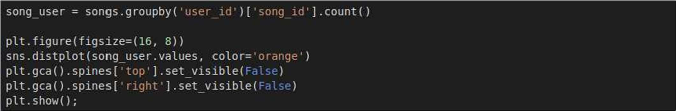

### Output:

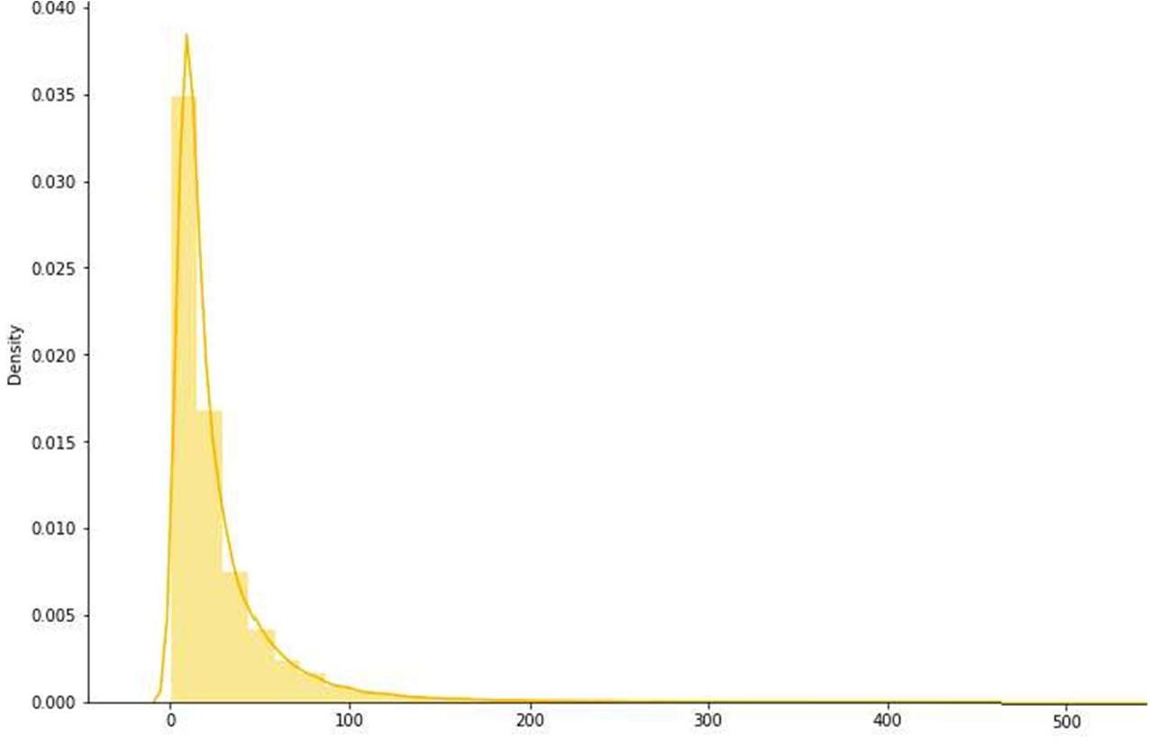

**Fig : Data Visualization**

**Choosing an algorithm and create a model**

The k-nearest neighbor algorithm (kNN) is a non-parametric machine learning method first developed by Evelyn Fix and Joseph Hodges in 1951 and later extended by Thomas Cover. It is used for classification and regression. In both cases, the input consists of the k closest training examples in the feature space.

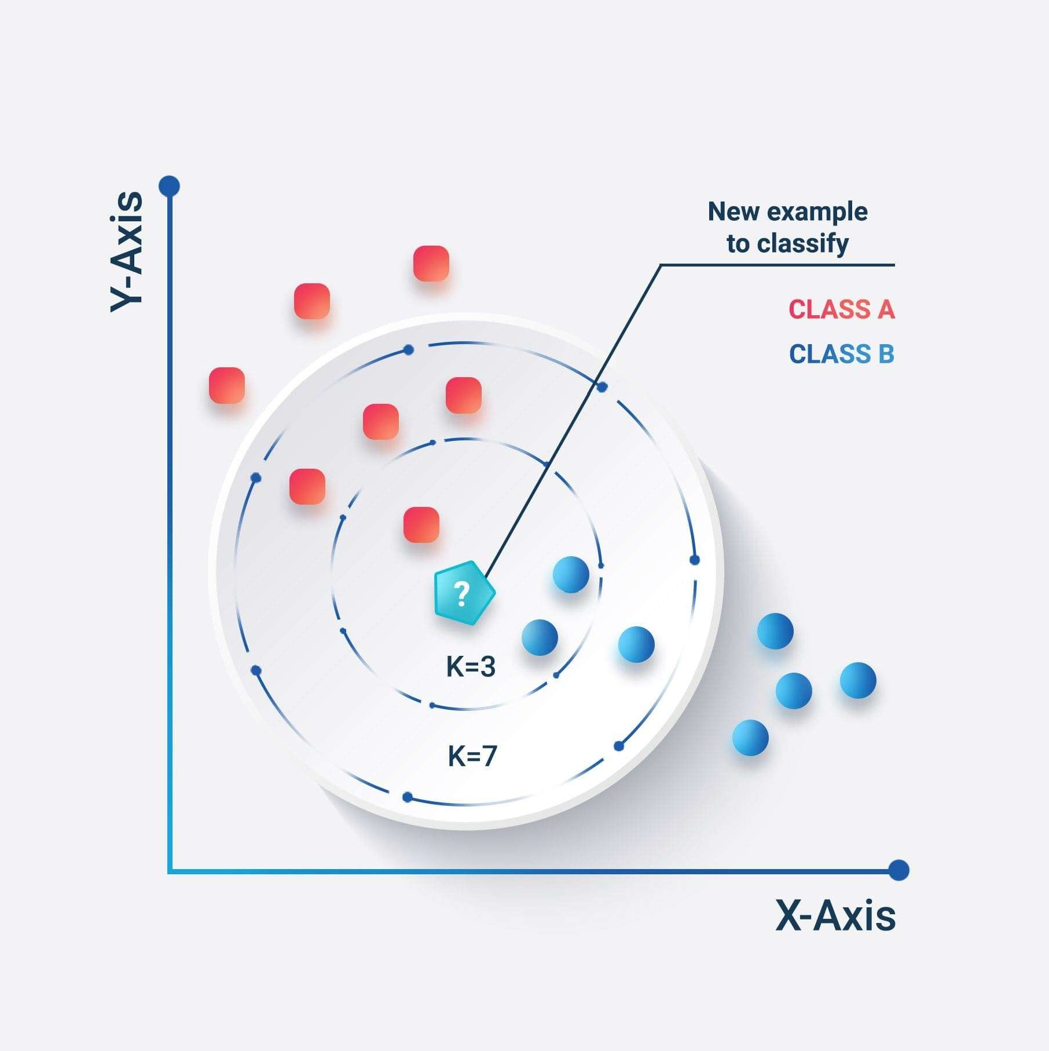

**Fig : Data Representation using KNN**

# Result of Music Recommendation System

sound_features = ['acousticness', 'danceability', 'energy', 'instrumentalness', 'liveness', 'valence'] fig = px.line(year_data, x='year', y=sound_features)

output:

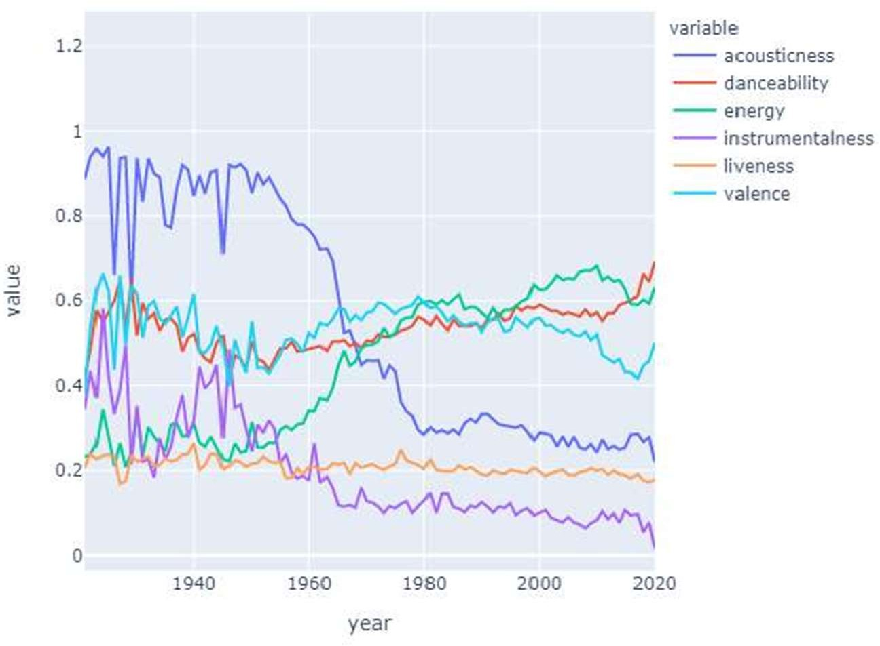

**Visualization of variables in a music**